Mexico City: An International Case Study for Mobility Planning
Sonia Raheel
Shiva Keyfanfar
The University of Memphis

Abstract
This paper explores issues in transportation planning and their resolutions within Mexico City. The idea behind the case study is to focus on how best to solve related problems in Memphis, TN. Prevalent themes indicated are environmental health, public health, and quality of life in connection with aspects of mobility. Plans, policies and programs implemented in Mexico were examined in conjunction with their outcome in Mexico City. This paper looks to Mexico City as a guide in how to better plan for mobility.
Keywords: mobility, transportation, pollution, Plan Verde, Metrobus

Mexico City: An International Case Study for Mobility Planning
It is one thing to suffer through a problem and complain about it, it is completely another to stand up and do something about solving the problem. Mexico City has adapted this approach by taking a stand against major issues like congestion and air pollution that are plaguing the city. Mexico City is located in the Valley of Mexico (Valle de Mexico), which is a large valley on the high plateau in the center of the country at an altitude of 2,240 meters (7,350 ft). The city has 16 boroughs which are divided into neighborhoods, and in the southern boroughs divided into towns and rural settlements. The Mexico City Metropolitan Area is also known as Greater Mexico City. This references cities, large towns and other urban areas connected to Mexico City. Strides have been made to improve the transportation within the region in many ways, particularly for environmental reasons and to improve quality of life. As Mexico City Mayor Miguel Mancera put it, “In Mexico City our mobility policy focuses on moving people through sustainable mobility, not on moving cars.” The city has developed different policy-programs like Hoy No Circula (Today Don’t Drive), Mexico City’s Metrobus, and Plan Verde (Green Plan) to benefit the city and its inhabitants and are constantly monitoring these programs improve their successes.
At the International Transport Forum a discussion report titled “Implementing Sustainable Urban Travel Policies in Mexico” was submitted describing the main challenges of urban travel in Mexico. In the report the annual population growth shows that growth between 1990 – 2010 was 1.6% being relatively lower than growth between 1970 – 1990 at 2.6%. The report discusses the contrast of people living in Mexican cities at 28.3% during the early 20th century, whereas, today 3 out of every 4 Mexican person(more than 86 million) lives in a city. It became obvious the need to create a higher standard of living for the people migrating to urban areas. This period of rapid growth proved troublesome for the city, with 18% of Mexico’s population living in Greater Mexico City as shown in Figure 1.
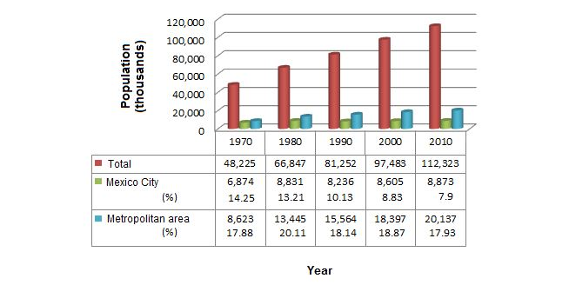
Figure 1. Population in Mexico, and Mexico City
During the 1994 and 2000 economic crises Mexico City people did not have the money to buy housing that was available in the market; so cheaper housing communities were built aiding the expansion of urban sprawl. Growing sprawl created the need for a transport system in the region. The existing public transportation system was inefficient causing people to begin buying cars. The buying power of citizens in Mexico City was limited so people turned towards purchasing used cars from the United States with high gas emissions rates. The most important information gleaned from these studies is that substantial growth in population had a positive impact on the economic development of Mexico City, but it led to people buying many more motorized vehicles leading to increased urban sprawl, congestion, and air pollution.
The government in Mexico City knew they had a big problem on their hands and it was important that it be addressed as soon as possible. A survey in 2007 pointed noted there were a total of 30.4 million modal trips being made daily in Mexico City Metropolitan Area by the various modes of transportation (See Figure 2).
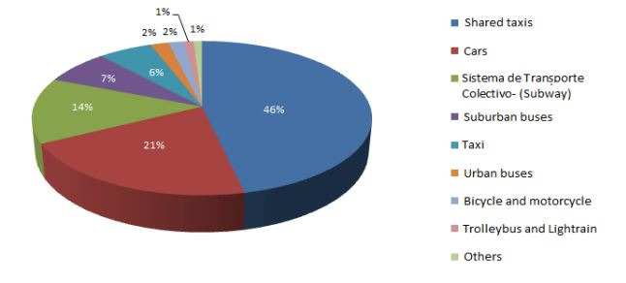
Figure 2. Modal split of trip in the Mexico City Metropolitan Area, during a typical day in 2007
Approximately 20 years ago high ozone levels along with airborne pollutants drove the government of Mexico City to introduce a program called Hoy No Circula banned certain drivers from using their cars during the week between 5 am and 10 pm. It worked as such: if a license plate number ended in 5 or 6 they were not allowed to use their car on Monday for the predetermined time. When this policy-program was implemented in 1989 the restrictions applied to the 2.3 million vehicles (460,000 vehicles per day). Initially it was presumed that this policy-program was working but a study conducted later found that the vehicle usage had increased significantly during the weekend which was having a greater impact on the airborne pollutants. This led the examiners to believe that the program was not as effective as it was considered to be and was tweaked until the intended goal was achieved.
To provide citizens with a more regularized public transportation system Mexico City’s Metrobus, a bus rapid transit (BRT) system, was started in 2005. One of the reasons for the failure of the existing public bus system was the each regular or mini-bus was owned by private owners. This system lead to confusion and disruption with routes among the area, with neighborhoods being overlooked and routes being replicated or prices not being consistent. This system was adding to the already rising air pollution. Implementation of Metrobus has resulted in various outcomes. It has improved environmental quality within the city, reducing CO2 emissions and particulate matter related to Nitrogen and Sulphur oxides. It has improved mobility by creating an efficient, safe, convenient and quick form of modern mass transit. It has contributed to the overall quality of life by reducing time stuck in traffic, number of traffic accidents due to better management of transit; reduction in noise pollution, number of respiratory problems, and increasing economic factors within the city at large.
BRT is a bus system that has been adapted by many countries worldwide and has proven success. The Federal District in Mexico City decided to implement the BRT system. The BRT was planned on a high-profile avenue running through the heart of the Mexican capital. This system has reduced travel times and improved mobility (Transforming, 2015). One of the major changes brought about in this system was the replacement of the 372 substandard buses. The first line to be introduced was the Original Line 1 running north to south being expanded upon in 2008 by the addition of 9 new stations. A Second Line was added in 2008 as well and this line serviced a small area from west to east along the Eje 4 Sur. The Third Line was added in 2011 which held significance because during the construction for every tree that was cut down another 3 were planted which was a great step in the improvement of public health. Later, Line 4, 5, and 6 were added and expanded upon in 2011, 2013 and 2014, respectively. A smartcard which is a prepaid ticket is commonly used for travel by Metrobus with a single trip costing $0.38 for regular riders and anyone over 70, disabled, or children under the age of 5 travel for free.
Another program-policy implementation was Plan Verde (Green Plan) in 2007. This plan under the government of Mayor Marcelo Ebrard was set to be a 15 year comprehensive plan. This plan was designed to move Mexico City towards EcoMobility as a transportation system that integrates socially inclusive and environmentally friendly focused modes of travel i.e. cyclist and pedestrian friendly. The plan is multilayered where its strategies are focused on reducing traffic congestion and greenhouse gases by focusing on 7 major points: land conservation, housing and public spaces, water supply and sanitation, transportation and mobility, air pollution, waste management and recycling, and climate change. Regarding mobility it's aiming to improve the efficiency of Mexico City’s public transportation system and promote non-motorized means of transportation. It is looking to create improvements to the city's public transportation system focusing on bus and subway route expansion
According to a report in 2011, 4 years after its implementation, the Green Plan has reached completion of 22 of the 76 goals with 31 of the remaining goals at 50% completion. The plan is working to educate and involve the citizens, stressing local action through already implemented programs and policies like Hoy No Circula (Today Don't Drive) and Muevete en Bici (Get on your Bike). Another notable assurance about this plan is that it has concrete implementation targets and effective systems to monitor the plan and its progress which are helping to personalize and tailor the plan according to need of each urban area.
The plans and policies that were implemented in Mexico City are some which could be utilized in the city of Memphis. Reducing the number of drivers, increasing the amount and effectiveness of public transit, creating pedestrian friendly modes of transport are all ways to help transportation in Memphis. Mexico City was able to drastically improve its quality of life by improving mobility for residents. The mobility planning conceived in Mexico City focused on themes which relate directly to problems in Memphis, mainly lack of transportation and sprawl. These reason are why Mexico City is a model for what can happen to improve Memphis. Improving the mobility for the city

References
"Green Living." Mexico City Experience : Green Living. Web. 22 Sept. 2015. http://www.mexicocityexperience.com/green_living/
Rivera, Hernández, Osorno, Zaragoza, and Ruvalcaba. "Implementing Sustainable Urban Travel Policies." (2002). Web.
"Sustainable Cities." Sustainable Cities. Web. 22 Sept. 2015. http://www.ggbp.org/report/best-practice-report/policy-design-and-implementation/sustainable-cities
"Transforming Transportation 2015." WRI Ross Center for Sustainable Cities. Web. 22 Sept. 2015. http://www.wricities.org/media/photo-essay/transforming-transportation-2015-smart-cities-shared-prosperity

All figures taken from Rivera, et al.

