Case Study on San Francisco, California
Design Collaborative Studio

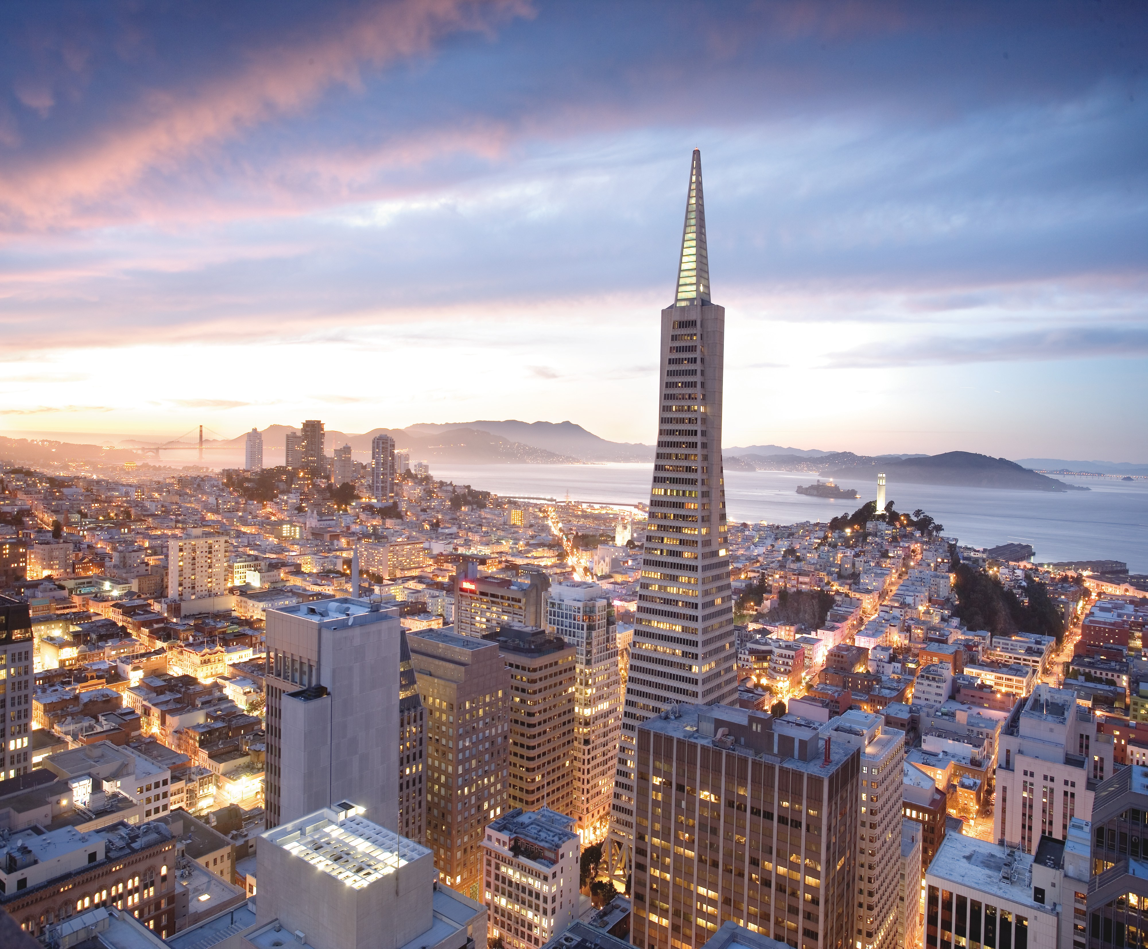

Presented by:
Robert Baxter, Ashley Espinoza, Marie Hayes, Martin Pantik, Bertram Williams

WHAT/WHEN
Pre-Conditions
San Francisco is a city in the United States that is well known for its beautiful views, slopes, and its trolley systems primarily intended for touristic purposes, but it was not always so. San Francisco’s transportation and highway systems were headed towards the direction of most American cities today. The Central Freeway, for example, is a highway that opened in San Francisco in 1959. It was envisioned to be the first leg of two crosstown highways that would connect the Bay Bridge to the Golden Gate Bridge. However, it came to pass that the citizens were not pleased, and started a “freeway revolt”, which is defined as a protest against the construction of highways, particularly in the 1960s and the 1970s. Figure 1 shows the initial plans for how the highway systems were to be implemented. These revolts were largely caused by the negative impacts that freeways tended to have on the community, creating sketchy areas with high crime and lack of security. Also, the noise pollution levels raised as these highway systems were created, altogether lowering the market values of the surrounding properties. Due to this “freeway revolt”, only 1.75 miles of the Central Freeway was constructed. The Central Freeway was a six-lane, elevated structure that eventually transitioned into a four-lane, two- level facility, running north towards Market, the city’s main street, into the Hayes Valley neighborhood, as shown in Figure 2. The freeway was known to carry as many as about 100,000 vehicles per day.

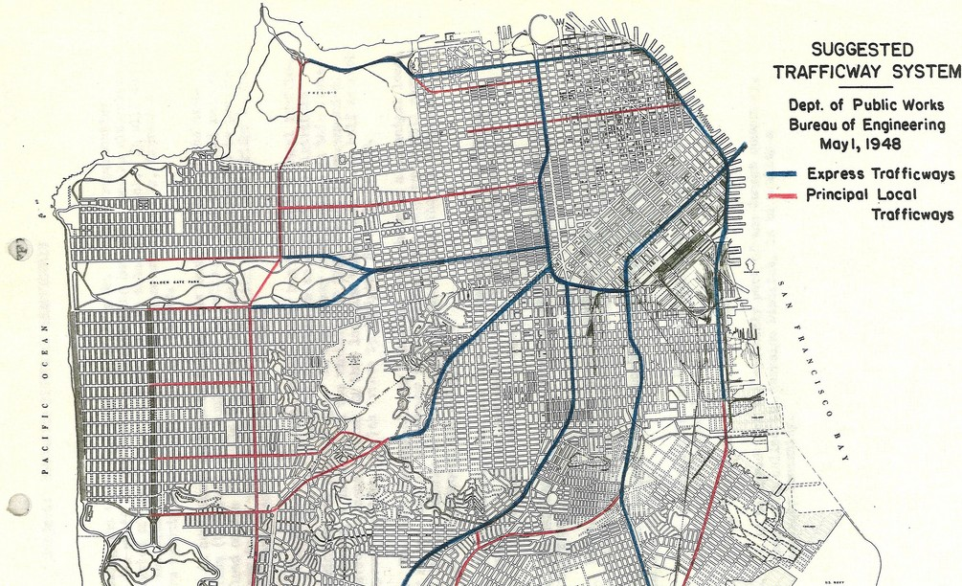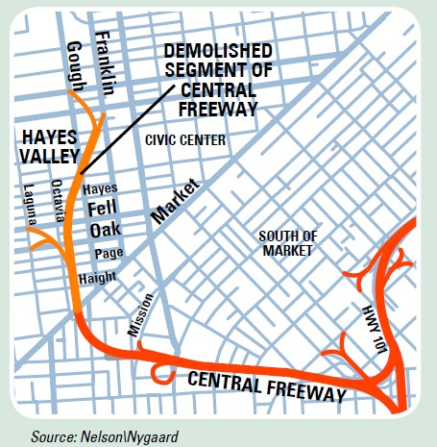

Figure 1- Suggested Trafficway System Figure 2 – Central Freeway

Post-Conditions
The Loma Prieta Earthquake of 1989 caused a turning point for the city of San Francisco and its mobility plan. The area north of Fell Street was demolished due to the damage caused by the earthquake. The citizens and the local officials began to consider new ways of approaching the idea of a highway, and it was soon played into action when the reconstruction of the bridge closed off on Market Street for several months, consequently allowing its nearby inhabitants to become accustomed to the low levels of noise, traffic pollution, and vibrations caused by the vehicles. As a result, the removal of highway systems in this area was voted for, and was replaced by a depressed freeway called Octavia Boulevard in 2005, as seen in Figure 3. Due to this transformation, the Hayes Valley, once known for its high crime, is now filled with shops, restaurants, and galleries, all while the property value of the area increased by over 30%.
Embarcadero, on the other hand (another highway system that was completely removed after the earthquake), was protested against by the Chinatown storeowners, due to the risk of their

businesses failing. Nonetheless, the removal of the Embarcadero occurred, and for some time it affected the businesses in Chinatown because of the new introductions of other businesses in the newly remodeled complete street. Today, Chinatown still stands, along with many other businesses in the sidelines of what was once the Embarcadero highway.

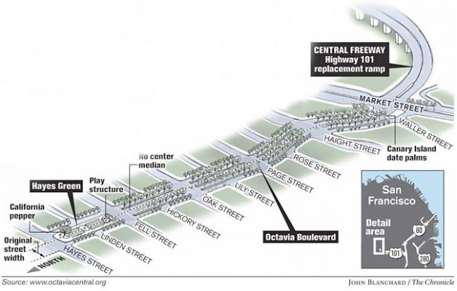
Figure 3 – Octavia Boulevard

WHERE
San Francisco, California is described as a 180° Waterfront Perimeter with a diagonal main street, or Market Street. The site itself is very hilly, creating walkability issues and transportation issues in the peak areas of topography, as seen in Figure 6.

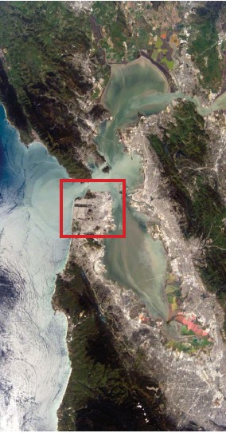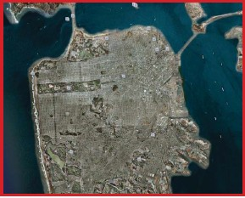

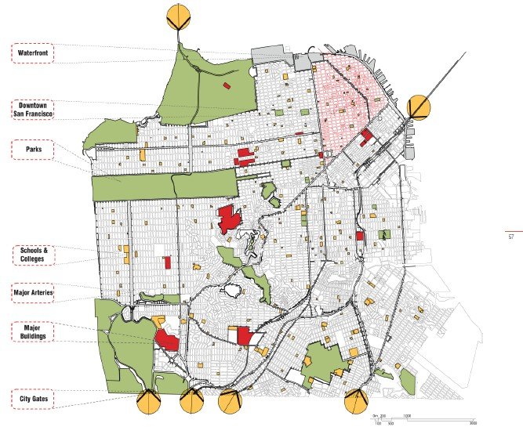

Figure 5 - Composition of San Francisco

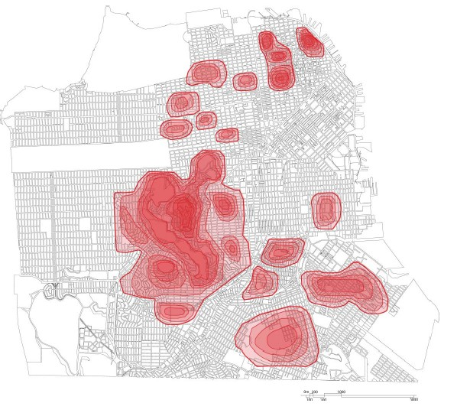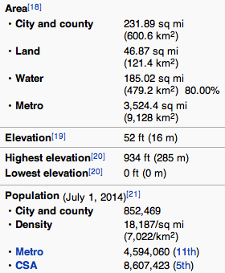

WHO
The main people involved in what resulted in the plans for San Francisco included the public officials of the city, the California Department of Transportation (Caltrans), The San Francisco County Transportation Authority, the citizens and voters in San Francisco, who were opinionative on what was occurring within the city regarding the construction of the highway systems. This particular solution towards a better transportation community impacted those particularly in the Market Street Area and the Hayes Valley Neighborhood (see Figure 8), due to its change in reputation and drastic change in market and property value. The BART system also helped shape and allow for better solutions on how people could get around, significantly impacting the Bay Area in San Francisco (see Figure 9).

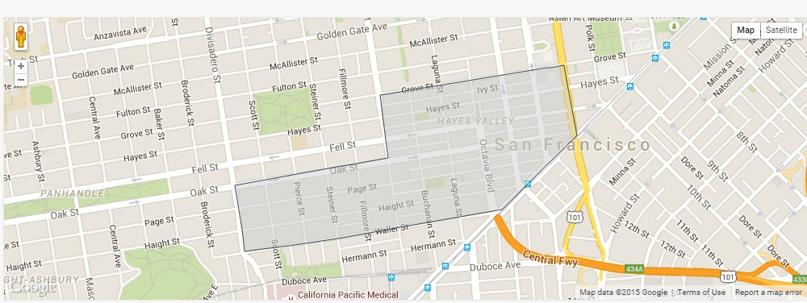

Figure 8- Hayes Valley Neighborhood

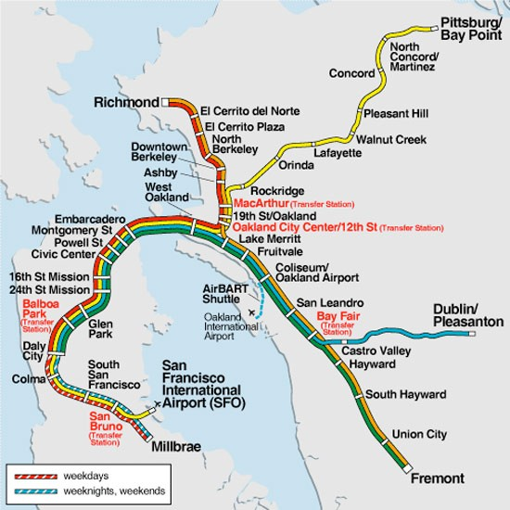

WHY
Lessons Learned
- Highway removal has the potential crime reduction in neighborhoods.
  - Hayes Valley has seen a major decrease in crime from 1996-2006 with a corresponding increase in home values over the same time period.
- Presents an opportunity for the construction of planned, mixed income housing
  - In a relatively small space of seven acres, around 800 units of housing are planned with about half being “affordable housing”.
- Revenue from the sale of new street frontage can fund other government projects.
  - The revenue was used to create a 16,500 sq.ft. park in the redevelopment area.
- “Spillover traffic can be absorbed”
  - Generally in cases where highway removal has happened, the traffic that was present on the highway can be readily handled by alternate routes. Additionally, behavior changes so that fewer trips are taken and trips are dispersed across an entire network system as opposed to funneling them through one route (the highway).
Potential Applications for Memphis
Sam Cooper Boulevard, shown in Figure 10, currently splits the eastern portion of Memphis, limiting access between the areas north of Summer and East Memphis. Removal of Sam Cooper would re-open North and South connections for pedestrians and bicyclists. Because Summer Avenue already runs parallel to Sam Cooper, East-West mobility would not be lost. Additionally, Summer Avenue has the potential to become a commercial corridor similar to Union Avenue. The space could also be redeveloped as a buffer zone for housing between the more affluent East Memphis neighborhoods to the South, and the more working-class neighborhoods to the North. Because of the presence of the good local schools near Sam Cooper’s East, housing should retain its value and potentially help to increase the values of North Summer.

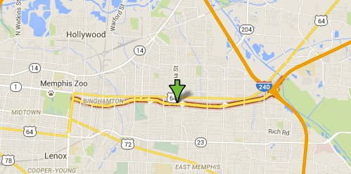

Works Cited
Frem, S. (2008). San Francisco. Mobility on Demand Urban Implementation, 59-83. Retrieved September 1, 2015, from http://smartcities.media.mit.edu/pdf/ Mobility_on_Demand_SanFranciscoCaseStudy.pdf

Hayes Valley, San Francisco Guide - Airbnb Neighborhoods. (n.d.). Retrieved September 15, 2015.

Looking at the BART map - 2 questions (Los Angeles, San Francisco: To rent, homes) - San Francisco - Oakland - California (CA) - City-Data Forum. (2012, December 14). Retrieved September 15, 2015.

San Francisco Bay Area Freeway and Bridge Plans. (n.d.). Retrieved September 1, 2015, from https://www.flickr.com/photos/walkingsf/sets/72157622139053795/

"San Francisco Central Freeway." Seattle Urban Mobility Plan. City of Seattle, 2008. Web. 1 Sept. 2015. <http://www.seattle.gov/transportation/docs/ump/06 SEATTLE Case studies in urban freeway removal.pdf>.

