Chicago 2040: A National Case Study of Mobility Planning
Emily Corban
The University of Memphis

Abstract

This paper explores issues in transportation planning and their resolutions within the Chicago, Illinois metropolitan area. The case study is primarily focused on the creation of the Chicago Metropolitan Agency for Planning and the GO TO 2040 comprehensive regional plan as it creates and prioritizes implementation strategies for successful completion of policy recommendations. The primary resource for this paper comes from the Chicago Metropolitan Planning Organization (2010) online documents regarding the GO TO 2040 plan. This paper looks to Chicago as a guide on how to better plan long-term for mobility in Memphis, TN.
keywords: mobility, transportation, invest, commitment, implement

Background:
Chicago is located in the Midwestern U.S. and the Great Lakes Region, The city is located in northeastern Illinois on the southwestern shores of Lake Michigan. It rests on a continental divide, connecting the Mississippi River and the Great Lakes watersheds including the Chicago and Calumet River. It’s history is closely tied to proximity to Lake Michigan where waterborne cargo was the preferred method of shipping. The city originally developed around the mouth of the Chicago river and its transportation sectors followed suit.
The Chicago GO TO 2040 Comprehensive Regional Plan was developed by the Chicago Metropolitan Agency for Planning in 2010. The CMAP is the official regional metropolitan planning organization for the northeastern counties: Cook, DuPage, Kane, Kendall, Lake, McHenry, and Will. They both develop and guide the implementation of the plan which had its roots in 2005 with the creation of the CMAP. The CMAP was created in 2005 by Public Act 094-0510 which merged the Chicago Area Transportation Study and the Northeastern Metropolitan Planning Organization (MPO). The State of Illinois legislation that created CMAP gave the agency the task of integrating the previously separate topics of land use and transportation into one agency that would protect natural resources, improve mobility, and minimize traffic congestion in the seven-county region. The CMAP is responsible for developing the region’s transportation plan that integrates transportation with land use, housing, economic development, open space, the environment, and other quality of life issues. The plan must be updated every four years and requires public participation and separate transportation improvement documents. The graphic below details the structure of the CMAP in government.

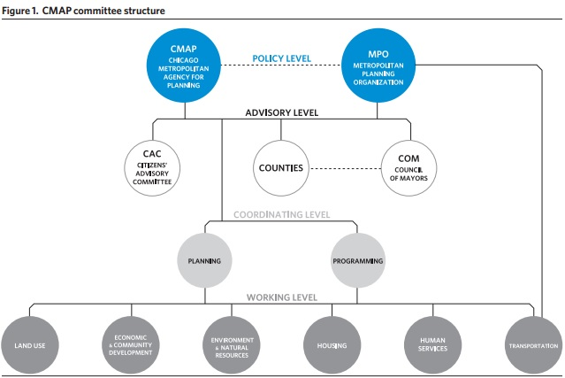
GO TO 2040 is the region’s official comprehensive plan and includes the sections Livable Communities, Human Capital, Efficient Governance, Regional Mobility, and Context and Best Practices. The section that focuses on transportation specifically is titled Regional Mobility.
However, many of aspects surrounding transportation are integrated into other sections as it impacts social justice, environmental sustainability, economic development, and public health. The plan itself consists of 417 pages, highlighted by four themed chapters and 12 high-priority recommendation sections. Each recommendation section includes Implementation Action Tables that describe strategic steps that are needed. The regional mobility section includes an additional section that overviews the capital investment that are recommended.
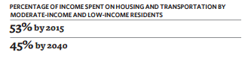

The Plan:
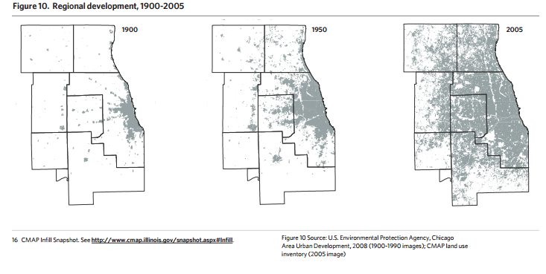
The plan is operated under the authorizing legislation Public Act 095-0677. The development of the plan started in 2007 with the creation of a regional vision and extensive input from public meetings and outreach. The CMAP produced a preferred scenario that was published in 2010 and based in part on forecasts for the region in 2040. The forecast was developed through the creation of a “reference scenario” based on base-year 2010 population and land use trends.Population in households for the region in 2010 was 8,291,066; The scenario projects the population to be 10,662,633 in 2040, a 28.6% change. The CMAP produces an annual work plan and budget document that guides the current fiscal year’s projects and they produce an annual report summarizing implementation each year. The Regional mobility section addresses the region’s transportation system, crucial for economic development and quality of life. The recommendation areas include: invest strategically in transportation, increase commitment to public transit, and create a more efficient network. The graphic below depicts the land use pattern of growth for the Chicago MSA.

Invest Strategically in Transportation
The plan calls on the federal government, the state of Illinois, transit agencies, and local governments to develop innovative financing to support a transportation system equipped for the new century.
The plan focuses on 5 implementation areas for investing strategically in transportation:

- Find Cost and Investment Efficiencies
  - project evaluation criteria should be improved, performance criteria should guide how funds are allocated, and allocations should be based on need
    - Prioritize maintenance and modernization projects when making investment decisions
    - Develop and utilize transparent evaluation criteria for the selection of projects, particularly ones adding capacity
    - Ensure that the region’s transportation projects are based on the above performance measures and align with the priorities of GO TO 2040
    - Improve decision making models used for evaluating transportation projects
    - Identify methods and technologies to improve operational efficiency of the transit system
    - Revise the federal “New Starts” program for transit
    - Develop regional infrastructure funding programs for plan implementation
    - End the “55-45” split for Illinois transportation dollars and make investment decisions based on metrics of need
    - Revise the process of state capital program funding in Illinois

- Increase Motor Fuel Taxes in the Short Term, and Institute a Replacement in the Long Term
  - levels should be increased from the existing 19 cents/gallon to 27 cents/gallon and index it to keep pace with inflation
    - Implement an eight cent increase of the state’s motor fuel tax and index it to inflation
    - Implement an increase of the federal motor fuel tax and index it to inflation rate
    - Conduct a detailed study of potential gas tax replacement revenue mechanisms, particularly “pay-as-you-drive” fees like a vehicle miles traveled fee

- Implement Congestion Pricing on Select Road Segments
  - apply supply-and-demand economic principles can reduce congestion by providing an incentive to alter travel behavior
    - Complete operational study of the potential congestion pricing projects
    - Implement congestion pricing pilot projects
    - Fund supportive transit projects with revenues generated
    - Fund arterial improvements with revenues generated
    - Conduct further study of congestion pricing and managed lanes strategies with special attention paid to major capital projects

- Implement Pricing for Parking
  - “free” parking perpetuates automobile dependency, increases congestion, and leads to economic inefficiencies.Pricing and related strategies can manage demand, promote efficient use of parking, and help fund needed improvements to existing transit. Some economists have suggested that municipalities charge a price that will ensure approximately 15% of parking spaces are always vacant.
    - Conduct detailed studies on potential parking pricing projects
    - Implement parking pricing, including variable pricing parking projects
    - Encourage sub-regional planning studies to include a parking pricing component

- Find Other Innovative Finance Mechanisms
  - Pursue appropriate public private partnerships.
    - Pass general state enabling legislation for public private partnerships
    - Provide objective analysis of potential projects and strategies
    - Consider public private partnerships in project development
    - Conduct detailed value capture studies

Increase Commitment to Public Transit

The plan wants to make transit the preferred travel option for as many citizens as possible. The plan must focus not just on how transit operates, but how it is perceived. Features that make “transit more attractive, such as clean stations, modern transit vehicles, clear information, and easy pedestrian access ( Chicago Metropolitan Planning Organization, 2011, p. 19).”

The plan focuses on four implementation areas for increasing commitment to public transit:
- Improve the Fiscal Health of Transit
  - Cost increases must be managed and additional revenue sources should be found
    - Strengthen RTA efforts on financial oversight
    - Direct a portion of congestion/parking pricing revenues to transit
    - Use other innovative funding sources
    - Revise the federal “New Starts” program for transit
- Modernize the Region’s Transit System
  - Some expansion of the current system is needed to match changing patterns of where people live and work. The CMAP supports the expansion of the region’s bus system.
    - Focus investments on maintenance and modernization
    - Adopt best practices in new technologies
    - Widely implement traveler information systems
    - Consider user perception in vehicle purchases, and station design
    - Establish seamless coordination between modes

- Pursue High-Priority Projects
  - The region focus on high-priority transportation projects that include a balance of transit, highway, and multimodal projects, distributed throughout the region.
    - Prioritize among potential bus service increases, extensions, and new service using regionally consistent criteria
    - Include transit components as part of major highway capital projects
    - Implement high-priority transit projects
    - Conduct detailed studies of prioritized corridors, and continually develop and evaluate major projects
    - Improve evaluation measures and decision-making processes
    - Increase federal investment in high-speed rail
    - Link high-speed rail with regional transit and land use planning

- Conduct Supportive Land Use Planning
  - Transit expansion efforts should include land use planning, local infrastructure investments that seek to create a transit-friendly environment.
    - Align funding for planning and ordinance updates
    - Identify and exploit additional opportunities for transit oriented development
    - Use livability principles to plan for land use in development near transit
    - Plan for land use specifically around major transit capital projects
    - Plan for land use specifically around BRT projects
    - Promote housing affordability near transit
    - Require supportive land use planning before new transit investment is made
    - Update guidelines for transit-supportive land use

The Benefits

A strong public transit system provides many benefits to the region including: economic, environmental, quality of life, and public health benefits. The primary economic benefits of transit comes through the additional mobility it permits- residents have more choices on where they live, work, and how they travel and can avoid harmful effects of congestion. Money invested in public transportation has the potential for a greater return on investment in the region.
Transit creates environmental benefits because it reduces emissions of pollutants and greenhouse gases. Public transportation uses half the amount of fuel/per passenger mile as private vehicles and shifts petroleum usage to electricity. Transit increases the quality of life by increasing the values of nearby land and supports non-motorized transportation systems as most transit trips begin or end with walking or biking, and improved walking and biking systems are linked with positive health outcomes.

Capital Investment

Major capital projects that have been evaluated to meet significant regional needs and which should have sufficient funds available, are included in a list of Fiscally Constrained Projects. While their costs are substantial, they represent less than three percent of the region’s projected $385 billion available for transportation through 2040, with 97 percent going to maintenance and modernization. The graphic below details the expected revenues for transportation from the federal, state, and local level.
Fiscally constrained major capital projects have the highest priority to move toward completion. They include transit, highway, and multi-modal projects.The majority of the high priority projects involve improvements to existing facilities. Topics include:
New Projects or Extensions
Expressway Additions and Improvements
Managed Lanes and Multimodal Corridors
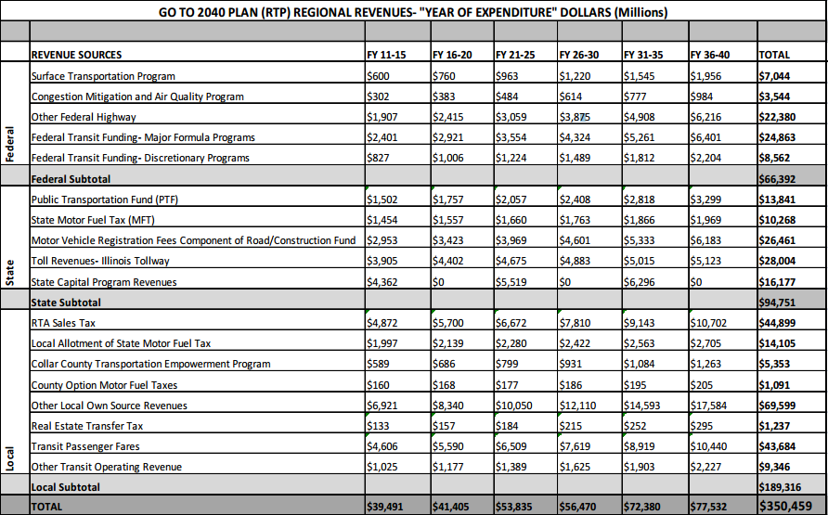
Transit Improvements

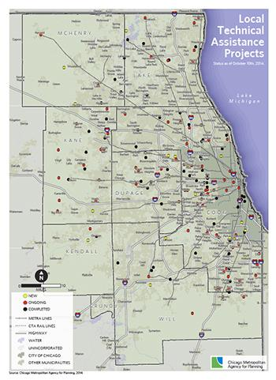
case studies:

The Chicago Metropolitan Agency for Planning has an interactive and visual infographic on their website for viewers to check out case studies of projects that are in various stages of implementation with links to project details. The case studies are examples of projects that are based on Go TO 2040 recommendations. These case studies provide examples of best practices that communities can look to for advice on implementing their own projects.
Chicago Forward

"Chicago Forward", produced by the Department of Transportation (2012) after the production of the GO TO 2040 plan, is consistent with many policies recommended in GO TO 2040. It is a good example of the stakeholders the GO TO 2040 plan states are responsible for working together to implement the comprehensive regional plan. The Chicago Forward plan includes many themes including “maintaining and modernizing the existing transportation system, promoting alternative modes of transportation, improving public access to information, protecting the natural environment, and enhancing the regional economy(Department of Transportation, 2012).” The plan places particular emphasis on supporting bicycle and pedestrian modes. The Chicago Forward plan is consistent with GO TO 2040 because of its comprehensive focus and performance measurement.

Works Cited:

The author, article title, journal name, issue, year and pages are formatted exactly like the print version. After the pages, list "Web" without quotation marks. Add a period. Indicate the day, abbreviation of the month and year you accessed the article.

Chicago Metropolitan Planning Organization (October 2010). GO TO 2040. 8 Sept 2015

Chicago Metropolitan Planning Organization (2011). GO TO 2040 Financial Plan for Transportation.. 9 Sept 2015

Department of Transportation (May 2012). Chicago Forward: Action Agenda. 8 Sept 2015

