Transportation Policies: A Case Study of Munich, Germany

By: Somer Smith - Group 3
University of Memphis Design Collaborative

Abstract
The purpose of this case study is to understand how Munich transformed its transportation system in order to determine best practices and their applicability to the Memphis Metropolitan Area. This report also examines how the change in transportation has positively affected four key indicators of Quality of Life: social justice, public health, the environment in which they live, and economic development.
Munich was able to strengthen already good public transit by promoting green sustainable ways of transportation, transit- oriented land use policies, and restricting the use of cars in the center city. Being the densest city in Germany, it was imperative to not only modify transportation policies, but to also accommodate for the growth and limit spraw. Planners focused on infill in order to take advantage of readily available land and to create new, mixed use neighborhoods so residents could get to their destinations without the need of cars. The transportation system policies of Munich stand as an example for what Memphis could possibly become with the application of appropriate systems, policies, and tools.

Introduction
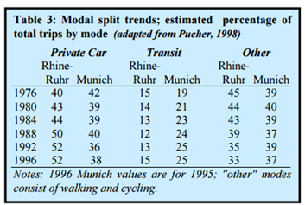
Munich is a model of how a city can be above the status quo and set itself apart from the communities that surround it. From the 1950s to the 1970s, there was increased car ownership and use throughout Germany. Munich was the exception, however. Munich chose to expand public transit, bicycling and walking, while decreasing its dependence on cars. In 1976, Germans made 40 percent of all trips by car. But by 1996, 52 percent of all trips in the Rhine-Ruhr metropolitan region, Germany’s most populated region, were by car. In contrast, the share of total trips by car in Munich declined from 42 percent to 38 percent over this same period. And, while the share of total trips by transit has been relatively flat in the Rhine-Ruhr metropolitan region, it has increased from 19 percent to 25 percent in Munich (The Tellus Institute, 1999). Unlike other cities, Munich’s transformation was less attributed to a specific policy or planning philosophy and more a result of “transit-led sustainable development pursued on multiple fronts” (Cervero, 1998, p. 215). These multiple fronts include transit-oriented land-use policies; steady expansion, improvement, and effective marketing of transit services; and restricting automobile use (The Tellus Institute, 1999).
Source: The Tellus Institute, 1999

Background
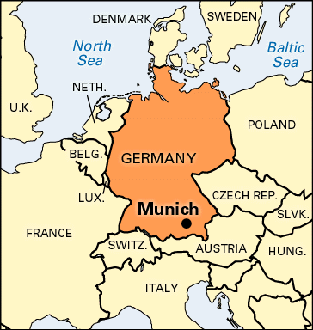
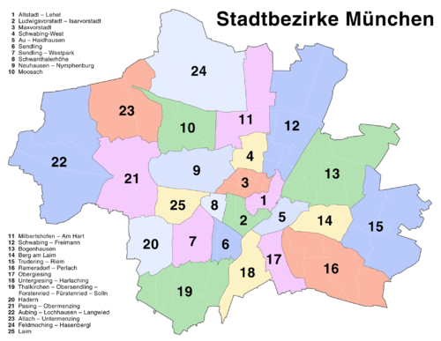
Munich, capital of Bavaria, is located in southeastern Germany. It is slightly north of the Alps and sits alongside the River Isar. The city of Munich is just under 120 square miles and contains 1.4 million people while the Munich Metropolitan Region contains over 5.5 million people (Martin Prosperity Institute, N.d.). Munich has the highest population density in Germany at 12,000 people per square mile and 25 distinct boroughs or Stadtbezirke, (World Population Review, 2015). Of the residents inside the city’s limits, about 300,000 do not have citizenship. Of the foreign nationals in Munich, about 37% come from European countries. The top five foreign nationals in Munich are: 43,000 Turks, 30,000 Albanians, 25,000 Croats, 24,000 Serbs, and 22,000 Greeks (World Population Review, 2015).
The climate is classified as Oceanic meaning that the average highs ranges from mid 20s degrees Fahrenheit in the winter to mid 70s degrees in the summer. Rain is is evenly distributed throughout the year so there is not a rainy season, however, areas closer to the Alps and higher in elevation tend to have more rainy or snowy days. The moderate climate of Munich makes outdoors modes of transportation such as walking and biking ideal.

Implementation
According to Cervero (1998), there are three land use prerequisites for sustainable and cost- efficient rail ways 1) a large, dominant center 2) dense residential development, radial corridors of development. All of these characteristics were present in Munich, allowing for the expansion of the railway system and the shift from the reliance of automobiles to more green ways of transportation from 1976-1996. The major parties in this movement were The Mtinchener Verkehrs-und Tarif-Verbund (MVV), the area wide transit authority; the Regional Association Munich, the regional planning agency; and, The Green Party, the anti-car organization.
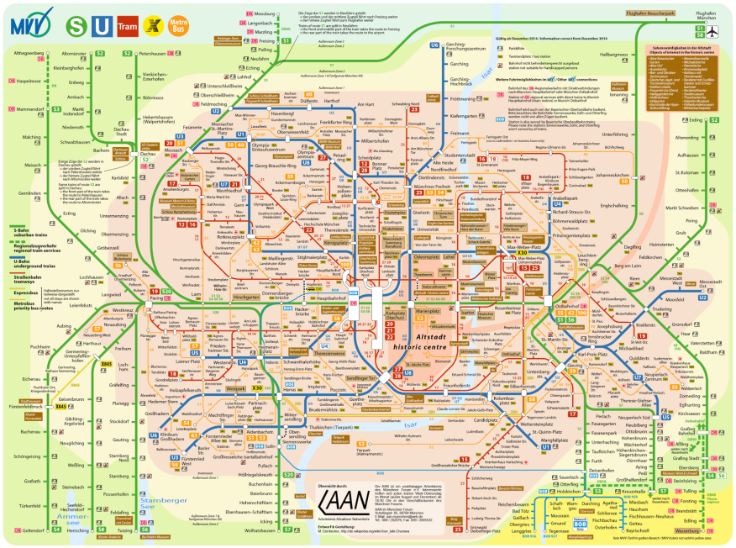
Examining Munich’s commuting patterns was a necessary first step to understand the land- use development patterns and how they affected the residents’ relationship with transportation. According to Cervero (1998), “Of the nearly 900,000 daily, motorized commuting trips to and from the city, about 67 percent (50 percent into the city and 75 percent within the city) are by public transit, an astoundingly high share,” (as cited in The Tellus Institute, 1999). This was crucial to the configuration of the new and improved railway system that transformed transportation in the metropolitan area. From this study, planners were able to understand that housing in the center city was desired. This encouraged infill of new developments in neighborhoods close to rail lines which has helped to make trains Munich’s second favorite mode of transportation (Cervero, 1998).
Another important factor that helped shape Munich’s transportation policies was the formation of an area wide authority, the Mtinchener Verkehrs-und Tarif-Verbund, or the MVV, which organized many components of the rail and bus operations such as fares, routes, and timetables (Cervero, 1998, p.214). The regional transit system would not have been able to collectively improve or expand without a central authority to make decisions.
Lastly, Munich had to limit the use of automobiles in order to make alternate forms of transportation more attractive. In order to reduce automobile use, the government instituted a “pull- push initiative” to pull people from their cars and push them to use greener, sustainable modes of transportation (Cervero, 1998). Measures used to push residents from their cars include restricting parking by doubling curbside parking rates, reducing time limits for metered parking to only an hour, and prohibiting the construction of new off-street parking garages. Other measures to pull people to from their cars were raising automobile taxes and registration costs. The increased fees also helped pay for the expansion of the different transit systems. Residents were then pushed to use other modes of transportation. The push initiatives were centered on making the use of transit extremely convenient. This was done by increasing park and ride locations, improving bus and train schedules, creating the S-Bahn and U-Bahn rail lines, and redesigning streets to ban cars and add bike lanes (Cervero, 1998). The presence of green space also helped to make being outside in the city more enjoyable and leisurely. The push initiatives made it more of a hassle to use a car than other options available in the center city

Effects on Quality of Life
The change in transportation has not only helped to make travel in Munich more efficient but it has also positively impacted social justice, public health, the environment, and economic development in the region. The following paragraphs describe how the implementation of mixed-use neighborhoods has helped to improve all sectors of quality of life and how the changes in each sector are related and dependent on the others.
Social justice has improved in Munich by making affordable transportation accessible for all levels of income. In some places, such as Memphis, TN, it is nearly impossible to get to parts of the city without a car. Those without cars either do not travel to those parts or must spend numerous hours on buses in order to get there. Munich was able to implement this by developing new mixed-income neighborhoods in close proximity to transit stations. Social justice is related to the other three sectors. Residents have access to transportation because of the infill of new mixed use neighborhoods. Because people live in a small area instead of spread out all over the region like in the Memphis example, things like jobs, grocery stories, and day care centers are only a short distance away. This positively affects economic development. Residents can reach their destinations by walking or biking or in a short train ride which increases public health. This in turn helps the environment by limiting the CO2 emissions from cars and reducing the amount of natural resources such as gasoline that are used.
Public health benefits have increased due to the development of mixed use neighborhoods as well. While it is true that some destinations are still too far to walk to in a timely manner, residents do have the option of riding bikes to their destinations. Cycling is encouraged by the addition of bike lanes and roads in which cars are not allowed. Another way mix use neighborhoods benefit public health is the proximity of homes to grocery stores. This basically eliminates the problem of food deserts. Residents can easily make their way to grocery stores to get fresh produce and vegetables instead of relying on corner stores that only sell frozen or prepackaged foods.
Economic development relates back to social justice and public health through the design and implementation of mixed income neighborhoods inside the city limits. This form of infill attracts a variety of people to the city. Whereas in most places, the wealthy are drawn to the suburbs, people of all income levels are present in downtown Munich. Filling vacant land with homes and increasing the city’s density also attracts businesses to the area. If there are many residents with easy access to transportation or who live in the area, the businesses will want to locate there in order to tap into the available work force and have a direct link to the consumers. Having new businesses operating in the city also brings and creates new jobs for residents. It is a win win (win) situation; there are more job opportunities for those who are unemployed, employees live close by their jobs making it easier and less time consuming to commute, and businesses are surrounded by their employees and customers.

Application for Memphis
While this case study proved to be very enlightening as a guide to better an already transit- oriented city, it is not applicable as a guide to completely transform a city that does not already have the transit “basics” that Munich did. The city of Memphis is the opposite of Munich in many ways. The land area of Memphis, 315 square miles, is almost triple the size of Munich’s while the population is less than half. Memphis is just not dense enough to use the same strategies as Munich. The ideologies and trends pre 1976 were ideal to foster the expansion of transit while in Memphis, beliefs would have to completely change in order to make any shift at all. The difference in ideologies can be attributed partly to culture, however. Owning a car is synonymous with the American way of life. While it was helpful to study Munich as a trailblazer in the age of transit reform, it would be more beneficial to study a city that started its transportation reform in the same state in which Memphis currently lies.

Reference List

Cervero, R. (1998). Making Transit Work in the Land of the Autobahn. In The transit metropolis a global inquiry. Washington, D.C.: Island Press.
Martin Prosperity Institute. (n.d.). Munich Metropolitan Region. Retrieved September 11, 2015.
The Tellus Institute, & Gurin, D. (1999, November 1). Putting the Brakes on Sprawl: Innovative Transportation Solutions From the U.S. and Europe. Retrieved September 11, 2015.
World Population Review. (n.d.). Munich Population. Retrieved September 12, 2015.

